NAME- RAHUL KUMAR

Experiment 1
1. Create an application to implement following method using Servlet.
- doPost method and print message "Welcome to J2EE tutorial".
- doGet method and print message "Welcome to Servlet tutorial".

Firstly we have create Dynamic Web Project, Under the “Dynamic Web Project” create a two file one is “html” and second is “servlet” under the servlet file we have passed “doPost method“ print "Welcome to J2EE tutorial",and under the “doGet method” print "Welcome to Servlet tutorial".
HTML Form (index.html)

<!DOCTYPE html>
<html>
<head>
<title>Experiment Servlet</title>
<style>
/* Styling the body to make it centered and visually appealing */
body {
font-family: Arial, sans-serif; /* Set a clean, readable font */
background-color: red; /* Light gray background for contrast */
margin: 0; /* Remove default margins */
display: flex; /* Use flexbox for centering content */
justify-content: center; /* Center content horizontally */
align-items: center; /* Center content vertically */
height: 100vh; /* Set full height of the viewport */
}
/* Styling for the container box */
.form-container {
background: white; /* White background for the container */
padding: 20px 30px; /* Add padding inside the container */
border-radius: 10px; /* Rounded corners for the container */
box-shadow: 0 4px 8px rgba(0, 0, 0, 0.1); /* Subtle shadow for depth */
text-align: center; /* Center the text inside the container */
width: 300px; /* Fixed width for the container */
}
/* Styling for the heading inside the container */
.form-container h2 {
color: #555; /* Dark gray text color for the heading */
margin-bottom: 20px; /* Add space below the heading */
}
/* Styling for the forms inside the container */
.form-container form {
margin: 10px 0; /* Add space between the forms */
}
/* Styling for the buttons */
.form-container button {
background-color: #FF0000; /* Red background color */
color: white; /* White text color */
border: none; /* Remove border */
padding: 10px 20px; /* Add padding for better appearance */
font-size: 16px; /* Set font size */
cursor: pointer; /* Show pointer cursor on hover */
border-radius: 5px; /* Rounded corners for the buttons */
width: 100%; /* Make buttons stretch to the container's width */
transition: background-color 0.3s ease, transform 0.3s ease; /* Add smooth transition effects */
}
/* Hover effect for the buttons */
.form-container button:hover {
background-color: #CC0000; /* Slightly darker red on hover */
transform: scale(1.05); /* Slightly enlarge the button */
}
/* Active effect for the buttons */
.form-container button:active {
background-color: #990000; /* Dark red on click */
}
</style>
</head>
<body>
<!-- Container to hold the form and buttons -->
<div class="form-container">
<!-- Heading inside the container -->
<h2>Click the buttons to make a request:</h2>
<!-- Form to send a POST request -->
<form action="Experiment" method="post">
<button type="submit">Send POST Request</button>
</form>
<!-- Form to send a GET request -->
<form action="Experiment" method="get">
<button type="submit">Send GET Request</button>
</form>
</div>
</body>
</html>

Servlet Code (Experiment.java)

import jakarta.servlet.ServletException;
import jakarta.servlet.annotation.WebServlet;
import jakarta.servlet.http.HttpServlet;
import jakarta.servlet.http.HttpServletRequest;
import jakarta.servlet.http.HttpServletResponse;
import java.io.IOException;

@WebServlet("/Experiment")
public class Experiment extends HttpServlet {
private static final long serialVersionUID = 1L;

public Experiment() {
super();
}

// Handles GET requests
@Override
protected void doGet(HttpServletRequest request, HttpServletResponse response) throws ServletException, IOException {
response.setContentType("text/html");
response.setCharacterEncoding("UTF-8");

// Generate HTML response
response.getWriter().println("""
<html>
<head>
<style>%s</style>
<title>Experiment Servlet</title>
</head>
<body>
<div class='form-container'>Welcome to Servlet tutorial</div>
</body>
</html>
""".formatted(getCSS()));
}

// Handles POST requests
@Override
protected void doPost(HttpServletRequest request, HttpServletResponse response) throws ServletException, IOException {
response.setContentType("text/html");
response.setCharacterEncoding("UTF-8");

// Generate HTML response
response.getWriter().println("""
<html>
<head>
<style>%s</style>
<title>Experiment Servlet</title>
</head>
<body>
<div class='form-container'>Welcome to J2EE tutorial</div>
</body>
</html>
""".formatted(getCSS()));
}

// Method to provide inline CSS for styling the response
private String getCSS() {
return """
body {
font-family: Arial, sans-serif;
background-color: blue;
margin: 0;
display: flex;
justify-content: center;
align-items: center;
height: 100vh;
}
.form-container {
background: white;
color: #FF0000; /* Changed color to red */
padding: 20px 30px;
border-radius: 10px;
box-shadow: 0 4px 8px rgba(0, 0, 0, 0.1);
text-align: center;
font-size: 24px;
}
""";
}

}
Output:-

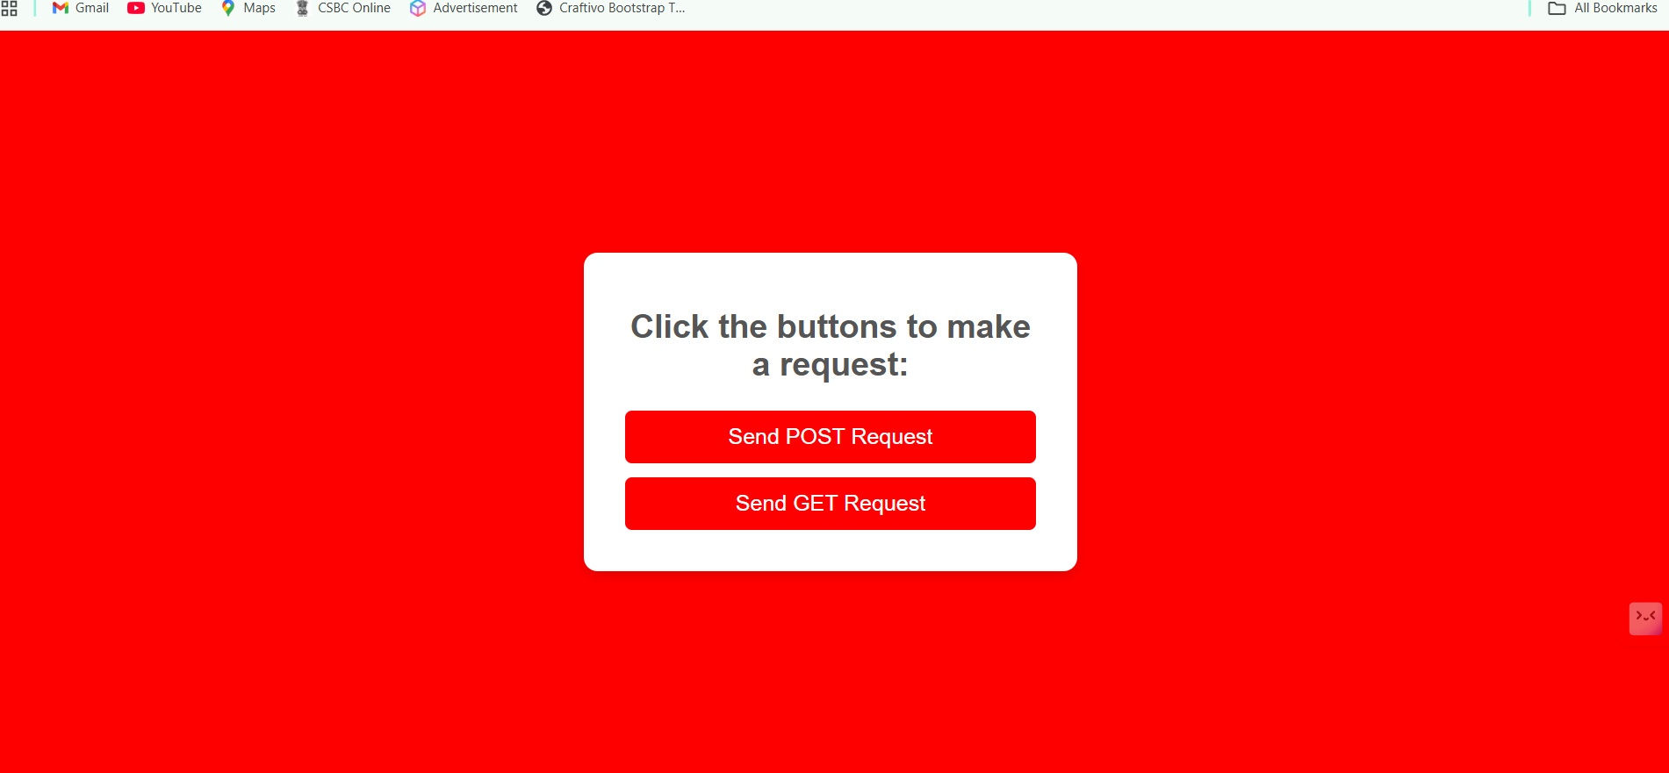

When i tap Send POST Request it will show this Output:

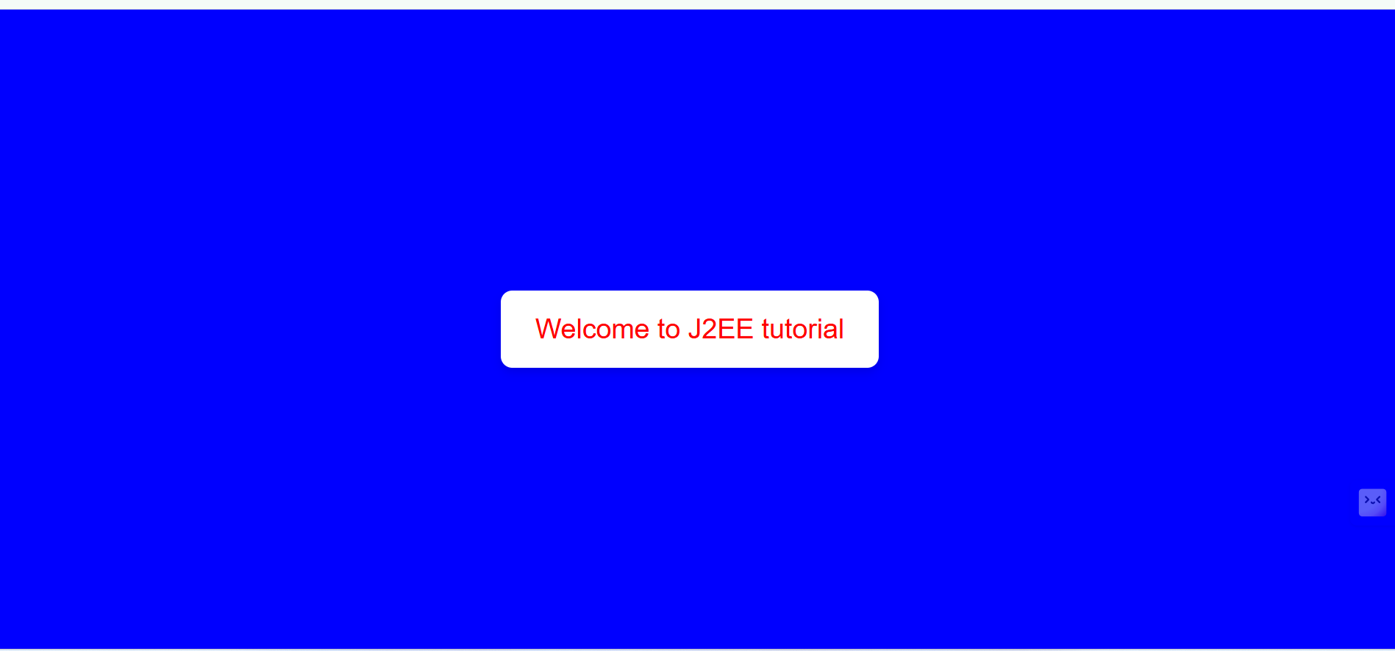

When i tap Send GET Request it will show this Output:

